Crowns Pending — Verification Required
Category: Crypto · Difficulty: Medium
Description | I begged my parents for MONTHS to get me the $5.99 Wizard101 membership but they HATE me and won't buy it for me. Then I got this video on my YouTube page on "How to get Free Wizard101 Crowns". I'm not tech literate so can you help me get my crowns?? My username is xx_BeastModeOnl1ne_xx.
Files | Single Docker container built from challenge/. Run these commands from this numbered folder, then open http://localhost:18104:  docker build -t rowdy-crowns04:review challenge  docker run -d --name rowdy-crowns04-review \  -p 18104:8080 --read-only --cap-drop ALL \  --security-opt no-new-privileges:true \  rowdy-crowns04:review  Players receive the website and its generation-log.txt and claim.json downloads. This document, screenshots, organizer files, source tree, and Docker image contain spoilers or private data; keep them organizer-only. Stop with docker stop rowdy-crowns04-review; reset with docker restart rowdy-crowns04-review. Regeneration and check commands are in organizer/OPERATIONS.md.
Hint(s) | 1. The generator negotiated two delivery keys. Keep both.  2. Different RSA moduli should not normally share a prime factor.  3. Compute their greatest common divisor, reconstruct Mirror A's private exponent, and decrypt its receipt.
Walkthrough | 1. Reach verification. Open the site, enter an optional fictional nickname, choose a Crown amount, and select Generate Crowns. Wait twelve seconds for the verification dialog and encrypted claim receipt. The realm choice is cosmetic; Sound On toggles the sound effects.  2. Save the evidence. Select Back to the delivery log, then expand both mirror entries under Delivery server log. Mirror A and Mirror B each supply a modulus, the large integer called n, and exponent 65537. Download the log and receipt. These Bash commands do the same; use Python 3.8 or newer. Inside Condev, first set export BASE=http://host.docker.internal:18104.  BASE="${BASE:-http://localhost:18104}"  mkdir crowns-solve  cd crowns-solve  curl -fsS "$BASE/generation-log.txt" -o generation-log.txt  curl -fsS "$BASE/claim.json" -o claim.json  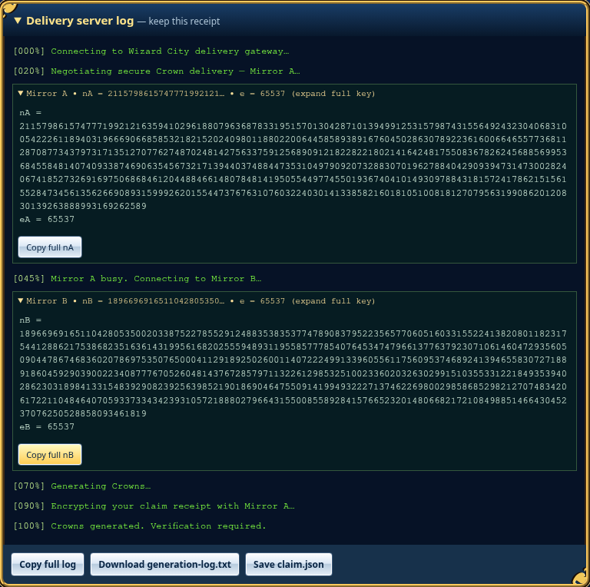  3. Identify the shared prime. RSA multiplies two secret primes to form each modulus. The mirrors reused one: nA = p × qA and nB = p × qB. Their greatest common divisor gives p, and division gives qA. The receipt identifies Mirror A and specifies raw RSA with no padding.  4. Decrypt the receipt. Compute phi = (p - 1) × (qA - 1). The modular inverse of e modulo phi gives the private exponent d; Python's pow(c, d, nA) then recovers the message integer. Convert it to big-endian bytes and decode ASCII, as the receipt specifies. Run this in the same shell:  cat > decrypt.py <<'PY'  import json, math, re  from pathlib import Path  log = Path("generation-log.txt").read_text()  receipt = json.loads(Path("claim.json").read_text())  def number(name):  return int(re.search(rf"^{name} = (\d+)$", log, re.M)[1])  nA, nB, e = number("nA"), number("nB"), number("eA")  assert receipt["key_id"] == "mirror_A"  assert e == number("eB") == 65537  c = int(receipt["ciphertext_decimal"])  p = math.gcd(nA, nB)  assert 1 < p < min(nA, nB)  qA = nA // p  d = pow(e, -1, (p - 1) * (qA - 1))  m = pow(c, d, nA)  assert pow(m, e, nA) == c  code = m.to_bytes((m.bit_length() + 7) // 8, "big").decode()  print("Modulus bits:", nA.bit_length(), nB.bit_length())  print("Shared prime bits:", p.bit_length())  print("Claim code:", code)  Path("claim-request.json").write_text(json.dumps({"code": code}))  PY  python3 decrypt.py  5. Check the result. The reencryption assertion confirms that the recovered message produces the original ciphertext. The output is:  Modulus bits: 2048 2048  Shared prime bits: 1024  Claim code: CROWN-9e7f4937af0b6da6a9b7fa9103597453  6. Redeem the code. Select Complete Verification to Claim to reopen the dialog. Paste the recovered CROWN-... value into the claim field and select Verify & Release Crowns. Alternatively, submit the JSON file created by the script:  curl -fsS "$BASE/api/claim" \  -H 'Content-Type: application/json' \  --data-binary @claim-request.json -o redemption.json  python3 -m json.tool redemption.json  The server returns the flag with “Crowns delivered: 0. Flag delivered: 1.” Select Copy flag to copy the reward.  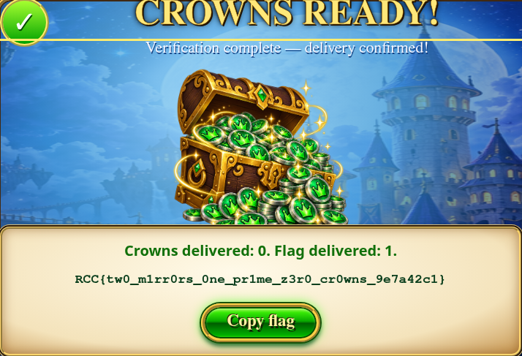
Flag | RCC{tw0_m1rr0rs_0ne_pr1me_z3r0_cr0wns_9e7a42c1}

